One-page abstract for ISPlasma2018/IC-PLANTS2018

¹Abc Firstauthor, ¹Def Secondauthor* and ²Hij Thirdauthor
¹Yyyyyy University, Japan

²Xxxxxx Institute of Technology, Japan
¹12-34 Abcdfg, Hijklmn, Nagoya 123-8888, Japan

²568-8 Gfdcba, Nmlkjih, Tokyo 456-9999, Japan
phone: +81-**-***-****, fax: +81-**-***-****
e-mail: corresponding author@***.***.ac.jp

1. Introduction
This leaf presents instructions for preparing one-page abstract to be included in the abstract book of ISPlasma2018/IC-PLANTS2018.

2. General Instructions
Please submit in PDF file format, using A4-size (210mm x 297mm) white bond paper. The abstract should have at least 300 words, one page maximum. If it is less or more than the specified quantity, it will be automatically rejected.
Set top and bottom margins to 25mm, left and right margins to 17mm. Both text and figures must fit inside this area as indicated by this sample. Each abstract will be printed out in reduced size, including the presentation number in black and white, Monotone.
Please use font type of Times New Roman (or similar fonts) with single spaced lines. It is possible for the title of the paper (14 points, bolded, first capital letter) to span a maximum of two rows. Author’s names should be written (12 points) in full. The presenting author’s name should be underlined. The corresponding author must be indicated with an asterisk. Author’s affiliations (12 points, italic) should be written in separate rows when there are several authors. The title, author(s), affiliation(s) and contact address should be written in single column. Abstract text (12 points) is arranged in two column format; paragraphs are to be indented, and each section is to be separated by one blank line. References should be listed at the end of the paper with square brackets (12 points) [1-3].

3. Submitting the Abstract

Only online submission via the ISPlasma website (http://www.isplasma.jp) will be accepted, NO LATER THAN 23:59 (Japan Time) Monday, Oct. 2 2017.

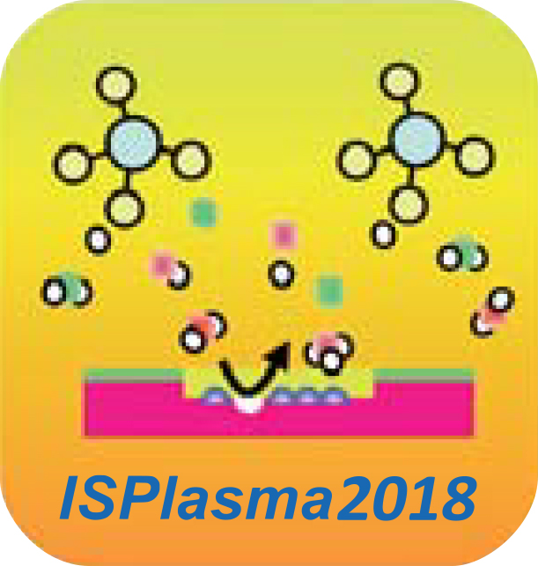

Fig. 1 ISPlasma2018 (Font for figure caption is 10pt)

4. Acceptance Notification/JJAP Special Issues
Notification of acceptance of paper will be sent to the corresponding author by the end of November 2017.

Acknowledgments
It is our pleasure to welcome you to the ISPlasma2018/IC-PLANTS2018 and discuss on distinguished topics on Plasma, Nitrides, Nanomaterials and Biosensing. We would be grateful if you could have fruitful discussions and beneficial synergies throughout this symposium.

References
[1] A. Bcdeasdf, F. Ghijk, L. Mnop, Q. Rstu and V. Wxyz: Appl. Phys. Lett. 71, 2067 (19xx).
[2] Z. Yxwv, U. Tsrq, P. Onml, K. Jihg and E. Dcba: Inst. Phys. Conf. Ser. No. 145, p. 000, (19xx).
[3] A. C. Egij, Jr. and L. N. Prtv: Heterostructure Lasers (Academic Press, New York, 200x), Part B, p. 71.

