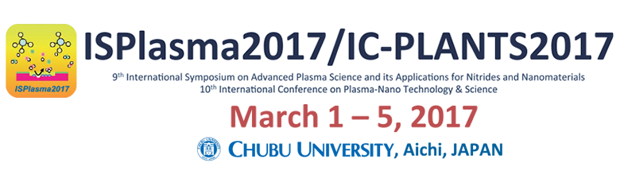
Application Form for Publishing Advertisements
Office for ISPlasma2017/IC-PLANTS2017
In Intergroup Corporation: Person in charge: Kengo Suzuki
8th floor, Orchid Bldg. 2-38-2 Meieki, Nakamura-ku, Nagoya City 450-0002
FAX: +81 52-581-5585 Email: isplasma2017@intergroup.co.jp
Application deadline:
Friday, December 16, 2017
Deadline for the ad data:
Thursday, December 22, 2017
FAX to: +81 52-581-5585

Application Date:

- Applicant for Publishing Advertisements * Necessary information will be sent to the person in charge (the contact person). If there are any changes, please inform us.
Name of your company, body or organization  (This will be displayed on your name board.) |  | Japanese (if any) | Katakana transliteration (if any)
 |  | English
Address |  |  | Katakana transliteration (if any)
 |  |  | TEL： | FAX：
Person in charge of this event | Name |  | Katakana transliteration (if any)
Person in charge of this event | Position & section
Email address of the contact person

- Application for Publishing Advertisements *Check the items that apply.
Content of advertisements
1 page/\50,000 × pages = \
* Enter the pages of the advertisements you would like to publish and the total amount of ad money.

■ On Bank Transfer
Information about the bank account into which you will pay will be offered on the bill after we accept your application form. Also, if you would like to designate your name and the subject name on the bill issued by us, please enter them in the Note blank below.* Due date: Friday, January 13, 2017
■ Note

